# IGNOU

##### Project Proposal (Synopsis) Of

**BACHELOR IN COMPUTER APPLICATION (BCA)**

**On**

*Institute Management System*

(Web Application)

Submitted By

**Enrollment No: - 185512614**

**Name: - Ujjwal Pandey**

**Course Code: - BCSP64**

**Regional Center: - Delhi RC-01**

INDIRA GANDHI NATIONAL OPEN UNIVERSITY

(SCHOOL OF COMPUTER AND INFORMATION SCIENCE **(SOCIS),**

(IST FLOOR, DEC BUILDING, **IGNOU,** MAIDAN GARHI, New Delhi – 110068.)

**TABLE OF CONTENTS**

**Page No.**

1. Introduction of Project ….03
2. Objectives of Project ….04
3. Project category ….05
4. Tools/Platform of Project – H/W and S/W ….08
5. Design of Project
   1. DFD ….09
   2. ER DIAGRAM ….
   3. DATA STRUCTURE ….
   4. Number of Modules & Their Description ….
   5. Process Logic of Modules ….
6. Types of information provided ….
7. Limitation of the Projects ….
8. Future Scope of Project ….
9. Bibliography ….

**INTRODUCTION**

**Institute Management System**

**Institute Management System** is the software made for the user and faculty to find, manage, and perform many functions. Many modules are included in the software to perform full operation like searching courses of the institute, getting full details about the respective course, get enrolled by filling a form with correct detail which on completion provide a pdf file having all submitted details with a unique enrolment no, find details about the institute and contact details, for faculty they can see no. of students in the institute in a list and full details of a student with their specific enrollment number, list of faculties in the institute and their detail, with all these only the owner will be able to add new faculty in the list of the institute.

At very first when a user will open the institute site, the site will open its home page which will contain a nice image with a logo and inspiring line at the center nothing else, but on scrolling it will show other content like achievements, few courses, hyperlink to all the courses page, about the institute and few location contactable details with a hyperlink containing full contact page which will have a form for user or guardian to contact online through an online form, mail, and mobile numbers to contact in the institute to clear all the query.

**OBJECTIVE OF THE PROJECT**

As the title of the project suggests, the objective of this software (web application) is to automate all the works (excluding teaching) of Institute related with the management of admission getting details etc. Some of the features of this software would be: -

* Creating a system to automate the services offered by the Institute Management, this would be more flexible than human to human contact as of today’s corona situation.
* It allows a user search for their loved and required course within the institute and get enrolled in it without coming in contact to other human and reduce the spread of COVID-19.
* It keeps track of the students enrolled till date and faculty in the institute.

**PROJECT CATEGORY**

* The project is based on **three tier architecture.** The three-tier architecture where the application is divided into three logical constituents
* User tier – Provide services such as user interface. (JSP, CSS, JavaScript, etc.) also known as **View**.
* Business tier – Implement business rules which will control how our web app will work (Java and JavaScript) also known as **Controller**.
* Data tier – Provide handling and validation of data getting and saving data in the database. (MySQL in this case) also known as **Model**.

Why three-tier not two-tier model or Disadvantages of two-tier architecture model**.**

* It puts extra load on the server
* It increases the network traffic.
* Difficult to implement incremental improvements.
* Applications are bound to the data source.

**REASONS FOR USING Eclipse**

Eclipse is a powerful Java project management and build management IDE. That means we can manage java project builds very easily using eclipse IDE. Eclipse can help us to minimize our project and build management time and efforts as comparison to any other non-ide code editor. It Is fine to manage project manually If It Is small. But If project Is very large like our and future project or there are many projects then It Is very hard for developer to manage each of them manually.

Using maven build tool, we can setup all those things which required to run your project code Independently. Maven provides common platform to generate source code, compiling and packaging code.

Advantages of Eclipse IDE project

* It makes project build process easy.
* It provides easy and uniform build system.
* It provides quality project document Information.
* Managing project dependencies.
* Provides guild lines for better project management practices.
* Facilitate easy and transparent migration to new features.
* It allows to build project using project object model (POM).
* It downloads required dependency's jar files automatically from Maven central repositories.
* Gives auto-correction and suggestions for code completion.

**THE ADVANTAGES OF RDBMS** (in my case- **MySQL**)

A database system is essentially a sophisticated, computerized record keeping system, a repository for a collection of computerized data files. A database system maintains information and makes that information available on demand, for this purpose a database system provides set of facilities to perform such operations.  
The benefits of a database system over any traditional system are obvious as database is integrated as well as shared, thus a database eliminates redundancy and also as a consequence, database lets multiple users access the same piece of data.

The most important advantage of the database is to maintain the integrity i.e., it ensures that the change made to the database by authorized users do not result in a loss of data consistency and guard against accidental damage to the database.

**RDBMS have the following facilities**

* Creation of files, Addition of data, Deletion of data, Modification of data.
* Retrieving data collectively or selectively.
* The data stored can be sorted or indexed at user’s discretion or direction.
* Various reports can be produced from the system. These may either be standardized reports or that may be specifically generated according to specific user definition.
* Mathematical function can be performed and the data stored in the database can be manipulated with functions to perform the desired calculations.
* To maintain data integrity and database use.
* Data integrity for multiple users.
* Providing form-based interface for easy accessibility and data entry.

# Major Advantages of Using MySQL

MySQL is a free-to-use, open-source database that facilitates effective management of databases by connecting them to the software. It is a stable, reliable and powerful solution with advanced features like the following:

## **Data Security**

MySQL is globally renowned for being the most secure and reliable database management system used in popular web applications like WordPress, Drupal, Joomla, Facebook and Twitter. The data security and support for transactional processing that accompany the recent version of MySQL, can greatly benefit any business especially if it is an eCommerce business that involves frequent money transfers.

## **On-Demand Scalability**

MySQL offers unmatched scalability to facilitate the management of deeply embedded apps using a smaller footprint even in massive warehouses that stack terabytes of data. On-demand flexibility is the star feature of MySQL. This open source solution allows complete customization to eCommerce businesses with unique database server requirements.

## **High Performance**

MySQL features a distinct storage-engine framework that facilitates system administrators to configure the MySQL database server for a flawless performance. Whether it is an eCommerce website that receives a million queries every single day or a high-speed transactional processing system, MySQL is designed to meet even the most demanding applications while ensuring optimum speed, full-text indexes and unique memory caches for enhanced performance.

## **Round-the-clock Uptime**

MySQL comes with the assurance of 24X7 uptime and offers a wide range of high availability solutions like specialized cluster servers and master/slave replication configurations.

## **Comprehensive Transactional Support**

MySQL tops the list of robust transactional database engines available on the market. With features like complete atomic, consistent, isolated, durable transaction support, multi-version transaction support, and unrestricted row-level locking, it is the go-to solution for full data integrity. It guarantees instant deadlock identification through server-enforced referential integrity.

## **Complete Workflow Control**

With the average download and installation time being less than 30 minutes, MySQL means usability from day one. Whether your platform is Linux, Microsoft, Macintosh or UNIX, MySQL is a comprehensive solution with self-management features that automate everything from space expansion and configuration to data design and database administration.

## **Reduced Total Cost of Ownership**

By migrating current database apps to MySQL, enterprises are enjoying significant cost savings on new projects. The dependability and ease of management that accompany MySQL save your troubleshooting time which is otherwise wasted in fixing downtime issues and performance problems.

## **The Flexibility of Open Source**

All the fears and worries that arise in an open source solution can be brought to an end with My SQL’s round-the-clock support and enterprise indemnification. The secure processing and trusted software of MySQL combine to provide effective transactions for large volume projects. It makes maintenance, debugging and upgrades fast and easy while enhancing the end-user experience.

**TOOLS/PLATFORM, HARDWARE AND SOFTWARE REQUIREMENT SPECIFICATION**

**Tools/Platform**

Project is developed using **Eclipse & MySQL 2017 command line** for storing data.

**🡪Use of Technologies/Tools**

*It is going to be a java web application.*

1. Unconditionally java
2. JSP
3. CSS
4. JavaScript
5. MySQL
6. Hibernate

**🡪Project type**

Maven project with java

**🡪Use of IDE**

Eclipse

**🡪Use of Browser**

Google Chrome, and

Microsoft Edge

**Hardware requirement Specification**

Altogether a Personal Computer with fallowing components**:**

To use Browser on Windows®, you'll need:

* Windows 7, Windows 8, Windows 8.1, Windows 10 or later
* An Intel Pentium 4 processor or later that's SSE3 capable (as we need only a browser)
* 2 GB Memory (RAM)
* Hard Disk 125 GB
* Color Monitor
* Keyboard
* Mouse
* Printer

**Software requirement Specification**

The software which was required for using the software is a new advanced web browser like google chrome, Microsoft edge, Opera.

**CONTEXT LEVEL DFD**

**Created on www.app.creately.com**

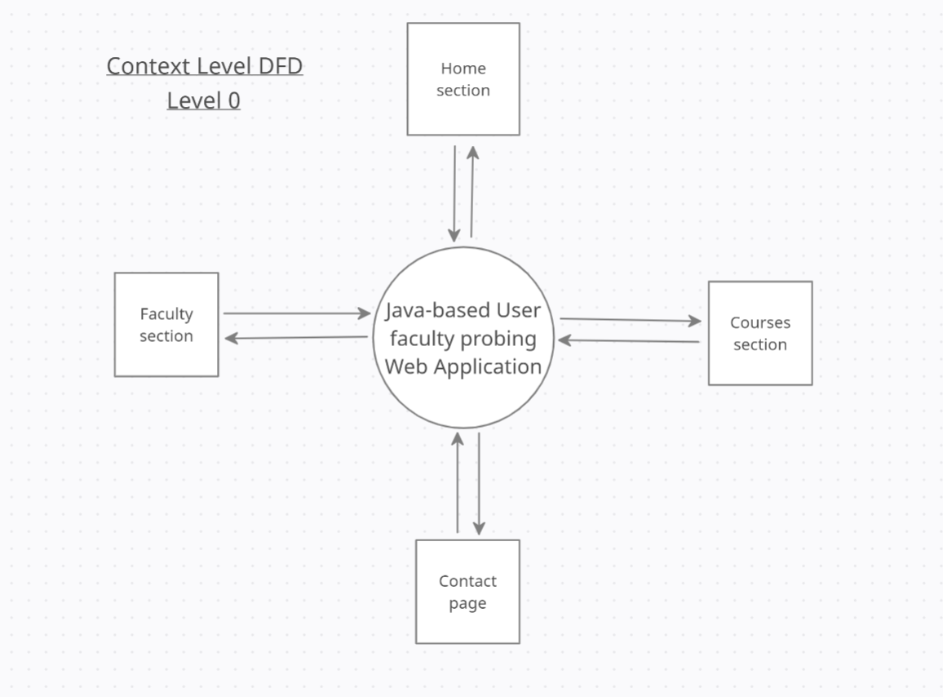

**CONTEXT LEVEL DFD**

**Created on www.app.creately.com**

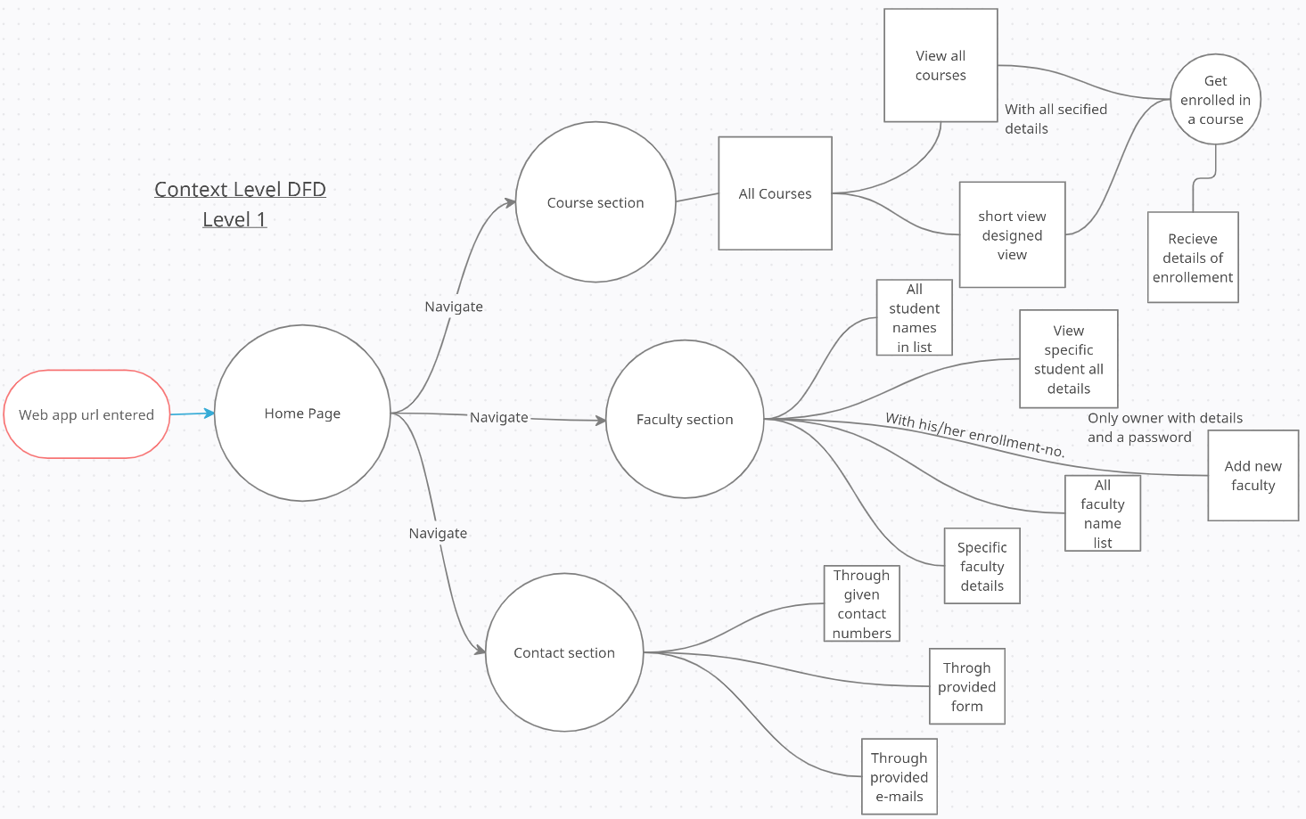

**ER-Diagram**

**Created on www.lucid.app**

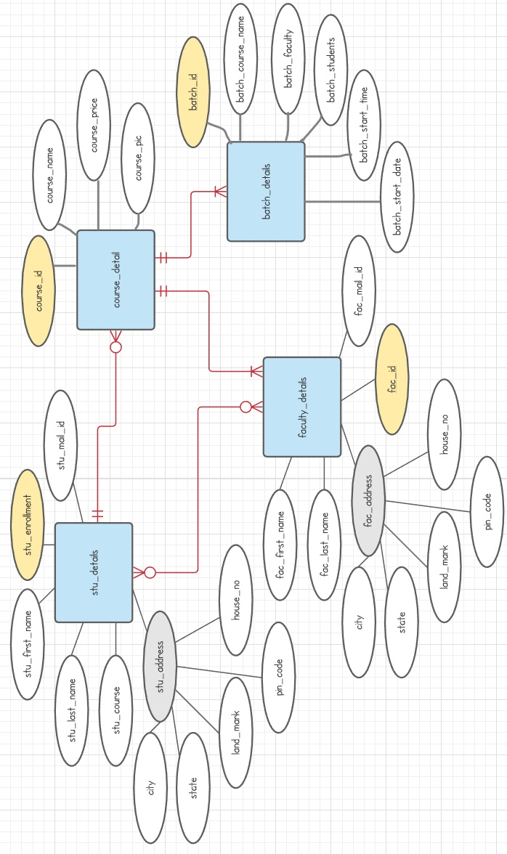

**Functions my project will have.**

1. Home page
   1. Intro
   2. About
   3. Achievements
   4. Hyperlink for courses
2. Courses page
3. Admission page
4. Check your courses
   1. List of all courses with price
   2. Link on a side for institute faculty for extra functionalaty
5. Faculty page are:
   1. Check all students (only name)
   2. Specific student details (full details)
   3. All student details (partial common details)
   4. List of faculties in the institute
   5. Add new faculty with a password (only know to owner)

**LIMITATION OF THE PROJECT**

* Needs internet connection
* Needs advanced browser which support new functions added after 2005

**FUTURE SCOPE OF THE PROJECT**

his project is designed and developed in such a manner that it provides maximum efficiency & speed and has a vast scope of further development. Number of modules can be added without many modifications in the database and with a minimum modification in it code. It is armed with a powerful query support system and is capable of supporting advanced and complex queries for much more advanced reports.

This application fits into the current scenario, which is the information age. This application with some modifications can be used by modern **Mobile Repairing Center** to automate their services, increase their efficiency and to make their presence felt in the present age of e commerce.

**BIBLOGRAPHY**

# WEBSITE –

# [www.google.com](http://www.google.com)

1. <http://www.microsoft.com/en-in/download/>
2. <https://www.javatpoint.com/mysql-tutorial>
3. <https://app.creately.com/diagram/IZYu0470DJu/edit>
4. [https://lucid.app/lucidchart/9e136d93-4545-4cd1-b26f-8bb69ac6484d/edit?beaconFlowId=E7D9D2D1265439AA&page=0_0#](https://lucid.app/lucidchart/9e136d93-4545-4cd1-b26f-8bb69ac6484d/edit?beaconFlowId=E7D9D2D1265439AA&page=0_0)
5. referenced books (all books of NIIT (I am a student of NIIT))
6. John Smiley, *learn to program with VB.Net 2005 Express,* 26 Aug 2008
7. Gary Cornell, *Jonathan Morrison, Programming VB.Net: A Guide for experienced Programming,* 15 Oct 2001
8. Andrew Troels, *Pro VB 2005 and the .Net 3.5 platform (Windows.net)*
9. IGNOU Blocks

referenced books (SQL Server 2005)–

1. Leonard Lobal, *Andrew J. Brust, Stephen Forte, Programming Microsoft SQL Server 2005 (Pro Developer),* 29 Oct 2008
2. Robert Vieira, *Professional Microsoft SQL Server 2005 Programming,* 23 Aug 2009
3. IGNOU Blocks